Name: Arpit Mahalle
Day 24 output screenshots
Challenge 1:
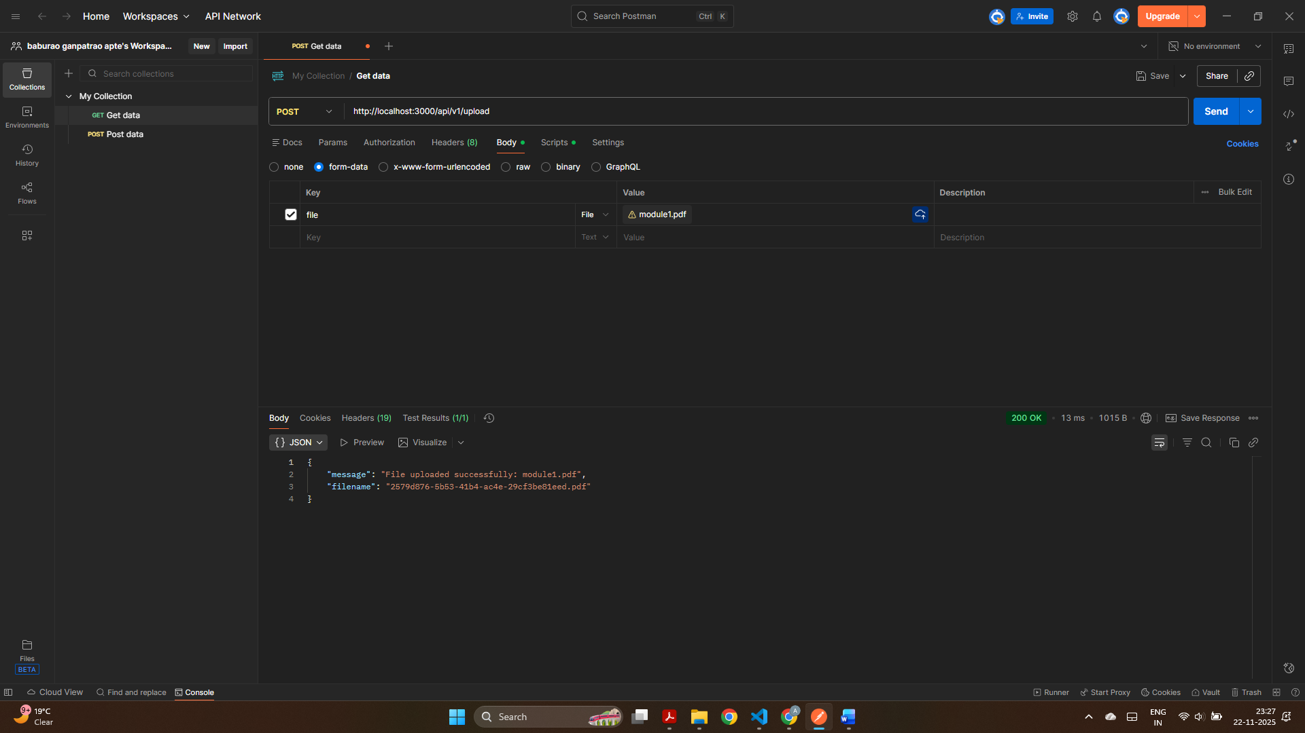
This shows a pdf is successfully uploaded using the /api/v1/upload endpoint in Postman. The API returned a JSON response with the original filename and the generated UUID filename.
Challenge 2:
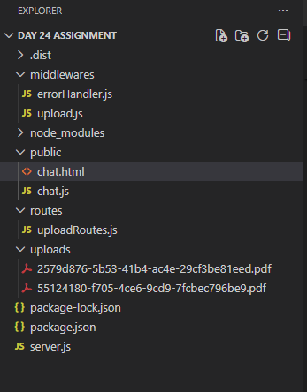
This screenshot confirms that uploaded PDFs are correctly saved in the /uploads directory with UUID filenames.
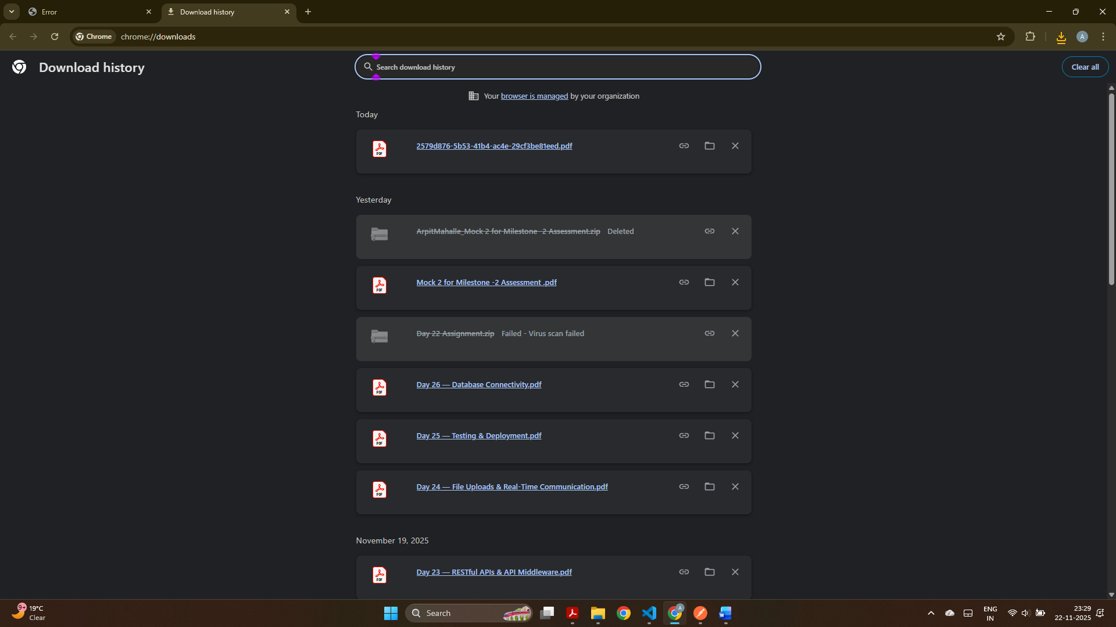
The uploaded PDF automatically downloaded through the /materials/<filename> route, confirming static file serving works correctly.

Challenge 3:
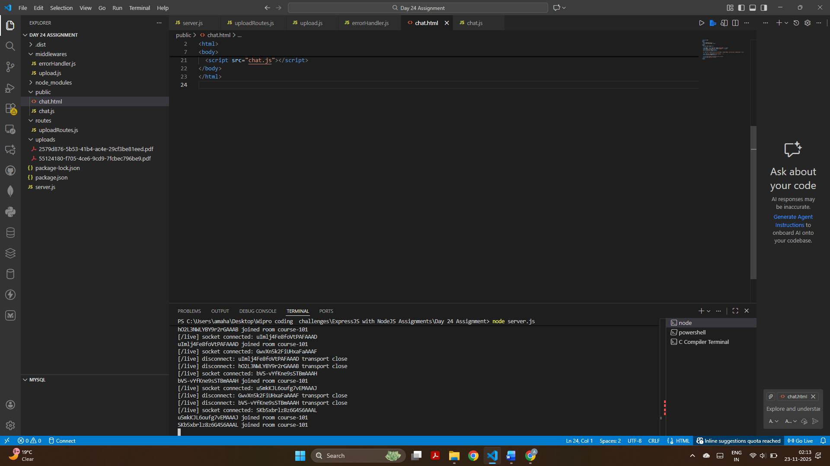
The terminal shows active socket connections joining rooms in real time.

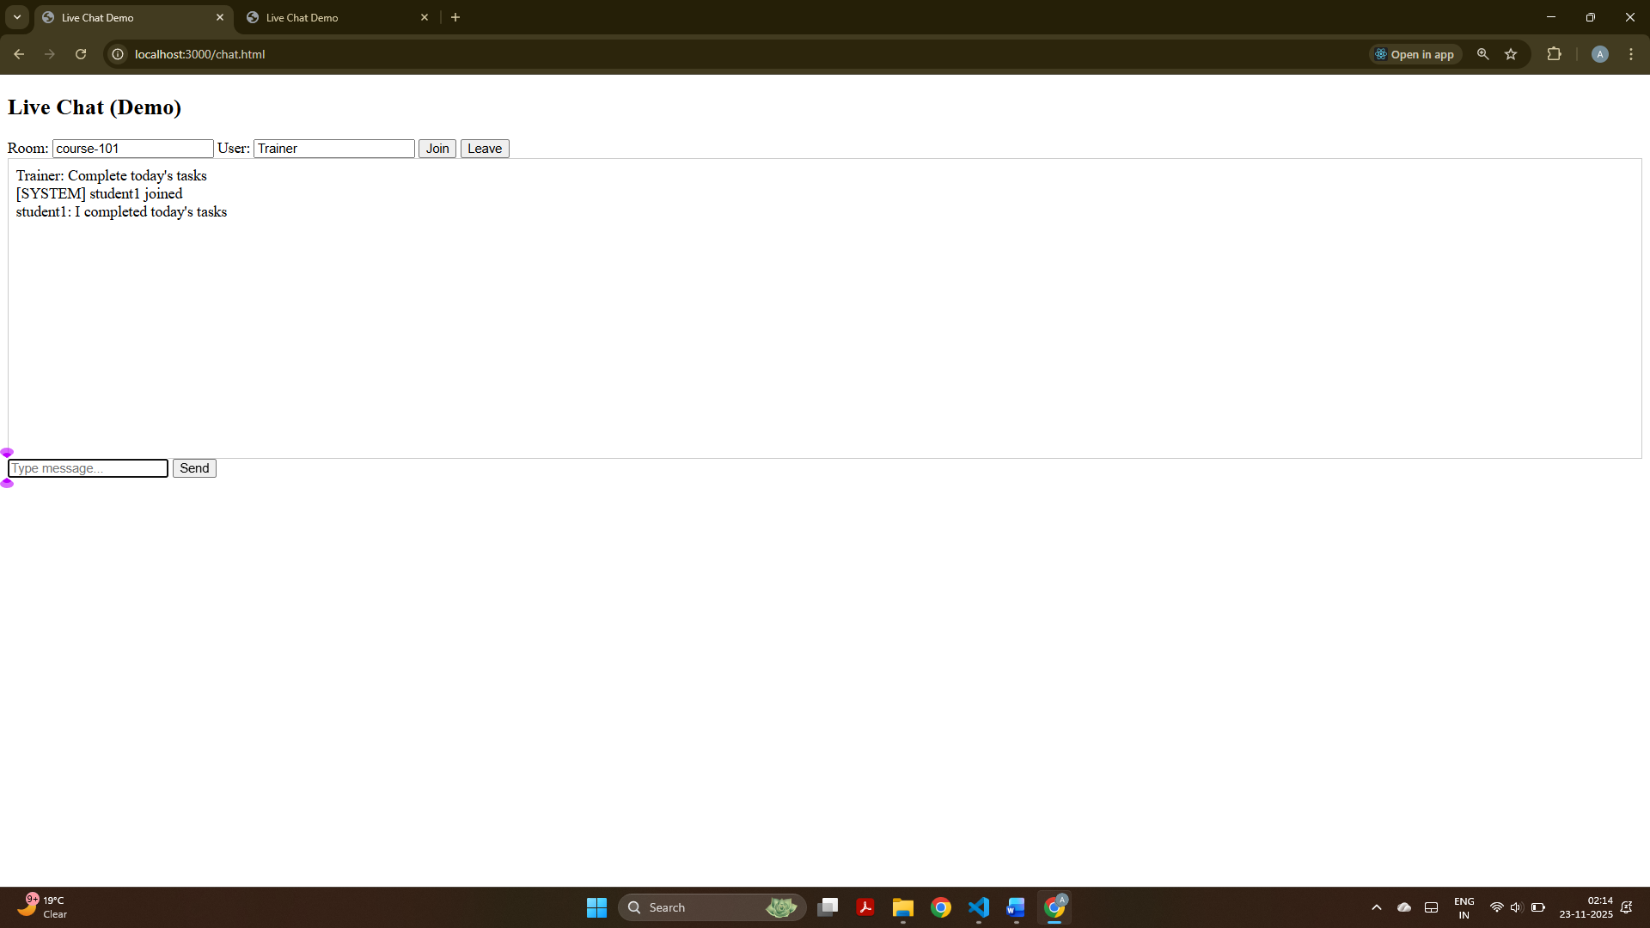
Trainer joined the chat room and exchanged real-time messages with students, displaying instant message broadcast and system notifications.

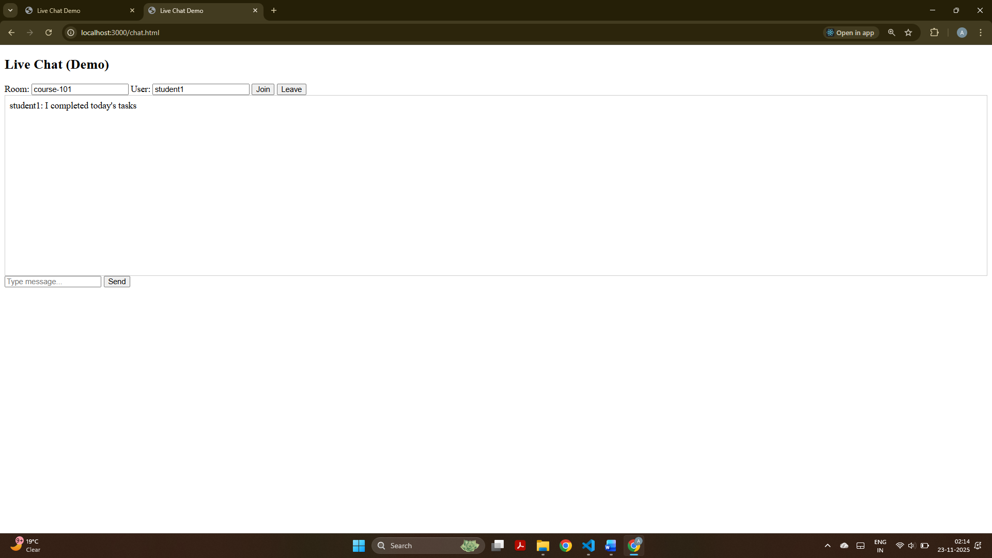
Student joined the same room and received all chat messages instantly, proving that real-time socket communication is working correctly.

